Q1:

#include <iostream>

using namespace std;

int main() {

int age;

string name;

cout<<"enter the name :"<<endl;

cin>>name;

cout<<"enter the age :"<<endl;

cin>>age;

cout<<"hello" <<name <<"you are" <<age <<"years old";

return 0;

}

enter the name :

uio

enter the age :

78

hellouioyou are78years old

Q2

int a,b;

cout<<"enter 2 values:";

cin>>a>>b;

cout<<"sum of no.s is "<<a+b;

enter 2 values:5 6

sum of no.s is 11

Q3:

int a, b ;

char opr;

cout<<"enter 2 values:";

cin>>a>>b;

cout<<"enter operator:";

cin>>opr;

switch(opr){

case'+':

cout<<a+b;

break;

case'-':

cout<<a-b;

break;

case'*':

cout<<a*b;

break;

case'/':

cout<<a/b;

break;

default:"no case";

}

return 0;

}

enter 2 values:7 9

enter operator:*

63

Q4:

float a,b ;

cout<<"enter 2 values:";

cin>>a>>b;

float c=a/b;

cout<<fixed<<setprecision(2)<<c;

enter 2 values:8 9

0.89

Q5:  
  
#include <iostream>

#include<cmath>

using namespace std;

int main() {

double p,r,n,t,ci,a;

cout<<"enter the principle:";

cin>>p;

cout<<"enter the rate:";

cin>>r;

cout<<"enter the number of time :";

cin>>n;

cout<<"enter the time:";

cin>>t;

r=r/100;

a=p*pow((1+r/n),(n*t));

ci=a-p;

cout<<"the amount:"<<a<<endl;

cout<<"the compound intrest:"<<ci<<endl;

return 0;

}

enter the principle:1000

enter the rate:5

enter the number of time :4

enter the time:60

the amount:19715.5

the compound intrest:18715.5

Q6:

#include <iostream>

#include<cmath>

using namespace std;

int main() {

float l,b,a,p;

cout<<"enter length:";

cin>>l;

cout<<"enter the breadth:";

cin>>b;

a=l*b;

cout<<"area:"<<a<<endl;

p=2*(l+b);

cout<<"perimeter:"<<p<<endl;

return 0;

}

enter length:5.3

enter the breadth:2

area:10.6

perimeter:14.6

Q7:

#include <iostream>

#include<cmath>

using namespace std;

int main() {

int a,b,c;

cout<<"enter 2 values:";

cin>>a>>b;

c=a;

a=b;

b=c;

cout<<a<<endl;

cout<<b<<endl;

return 0;

}

enter 2 values:5 6

6

5

#include <iostream>

#include<cmath>

using namespace std;

int main() {

int a,b,c;

cout<<"enter 2 values:";

cin>>a>>b;

a=a+b;

b=a-b;

a=a-b;

cout<<a<<endl;

cout<<b<<endl;

return 0;

}

enter 2 values:5 6

6

5

Q8-

#include <iostream>

using namespace std;

int main() {

int age;

string name;

cout<<"enter the name:";

getline(cin,name);

cout<<"enter the age:";

cin>>age;

cout<<"hello"<<name<<"i have lived for "<<age;

return 0;

}

enter the name:hui

enter the age:7

hellohuii have lived for 7

Q9  
#include <iostream>

#include<iomanip>

using namespace std;

int main() {

string ch;

int num;

float numm;

cout<<"enter the ch:";

getline(cin,ch);

cout<<"enter the num:";

cin>>num;

cout<<"enter the floating value:";

cin>>numm;

cout<<"+---------------+----------------+-------------+"<<endl;

cout<<"| character | integer | flaoting |"<<endl;

cout<<"+---------------+----------------+-------------+"<<endl;

cout<<setw(15)<<ch<<"|"<<setw(15)<<num<<"|"<<setw(15)<<fixed<<setprecision(2)<<numm<<"|"<<endl;

cout<<"+---------------+----------------+-------------+"<<endl;

return 0;

}

enter the ch:poi

enter the num:896

enter the floating value:21.3

+---------------+----------------+-------------+

| character | integer | flaoting |

+---------------+----------------+-------------+

poi| 896| 21.30|

+---------------+----------------+-------------+

Q10:  
  
#include <iostream>

using namespace std;

int main() {

int a,b;

cout<<"enter 2 values:";

cin>>a>>b;

if(b!=0 && a%b==0){

cout<<b<<" is multiple of"<<a<<endl;

}else{

cout<<b<<" is not multiple of"<<a<<endl;

}

return 0;

}

enter 2 values:8 4

4 is multiple of8

Q11  
  
#include <iostream>

using namespace std;

int countbits(int num){

int count=0;

while(num>0){

if(num &1){

count++;

}

num=num>>1;

}

return count;

}

int main() {

int num;

cout<<"enter the integer :";

cin>>num;

unsigned int unsignednum=static_cast<unsigned int>(num);

int result=countbits(unsignednum);

cout<<"noo of 1 bits:"<<result<<endl;

return 0;

}

enter the integer :7

noo of 1 bits:3

Q12

#include <iostream>

#include <cmath>

using namespace std;

int main() {

int a, b, c;

cout << "Enter coefficients a, b, and c: ";

cin >> a >> b >> c;

)

if (a == 0) {

if (b == 0) {

cout << "No solution exists (invalid equation)." << endl;

} else {

int root = -c / b;

cout << "Linear equation solution: x = " << root << endl;

}

} else {

int D = b * b - 4 * a * c;

if (D > 0) {

int sqrtD = sqrt(D); // sqrt(D) gives the square root

if (sqrtD * sqrtD == D) { // Check if sqrt(D) is an integer

int root1 = (-b + sqrtD) / (2 * a);

int root2 = (-b - sqrtD) / (2 * a);

cout << "Two distinct real roots: x1 = " << root1 << ", x2 = " << root2 << endl;

} else {

cout << "Non-perfect square discriminant. Cannot calculate integer roots." << endl;

}

} else if (D == 0) {

// One real and equal root

int root = -b / (2 * a);

cout << "One real root (equal roots): x = " << root << endl;

} else {

// Complex roots

cout << "Complex roots: Cannot solve with integer calculations." << endl;

}

}

return 0;

}

Enter coefficients a, b, and c: 1 -5 6

Two distinct real roots: x1 = 3, x2 = 2

Q13:

#include <iostream>

#include<cmath>

using namespace std;

int main() {

int balance=5000;

int pin=1234;

int enteredpin;

int option;

int amount;

cout<<"enter the pin:";

cin>>enteredpin;

if(enteredpin != pin){

cout<<"wrong pin.access denied";

return 0;

}

do{

cout<<"1.withdrwal";

cout<<"2.deposit";

cout<<"3.balance inquiry";

cout<<"4.exit";

cout<<"enter the option(1-4):";

cin>>option;

switch(option){

case 1:

cout<<"enter the amount to be withdrawn:";

if(amount<=0){

cout<<"it has to be grater than zero";

}else if(amount >balance){

cout<<"sorry the amount is not available";

}else{

balance-=amount;

cout<<"the amount is withdrawn"<<balance<<endl;

}

}

break;

case 2:

cout<<"enter the amount to deposit:";

cin>>amount;

if(amount<=0){

cout<<"amount should be more than zero";

}else if{

balance+=amount;

cout<<"deposit successfully.new balance:"<<balance<<endl;

}

break;

case 3:

cout<<"your current balance:"<<balance<<endl;

break;

case 4:

cout<<"exit";

default:

cout<<"invalid option";

}while(option!=4)

}

return 0;

}

Enter your PIN: 1234

ATM Menu:

1. Withdraw

2. Deposit

3. Balance Inquiry

4. Exit

Choose an option (1-4): 1

Enter amount to withdraw: 1000

Withdrawal successful. New balance: 4000

Q14

#include <iostream>

#include<cmath>

using namespace std;

int main() {

int s1,s2,s3;

cout<<"enter 3 values:";

cin>>s1>>s2>>s3;

if(s1==s2&&s2==s3&&s1==s3){

cout<<"it is an equilateral triangle:";

}else if(s1==s2||s2==s3||s1==s3){

cout<<"it is an isosceles triangle";

}else{

cout<<"it is an scalene triangle";

}

return 0;

}

enter 3 values:65 45 65

it is an isosceles triangle

Q15

#include <iostream>

#include<cmath>

using namespace std;

int main() {

int a ,b,c,d,e;

cout<<"enter 4 values:";

cin>>a>>b>>c>>d;

e=(a^b)+(c&d);

cout<<e<<endl;

return 0;

}

enter 4 values:5 3 7 2

8

Q16:

#include <iostream>

using namespace std;

bool isoppositesigns(int a,int b){

return (a^b)<0;

}

int main() {

int x=-2,y=10;

if(isoppositesigns(x,y)){

cout<<"are of opposite signs"<<endl;

}else{

cout<<"are of same sign"<<endl;

}

return 0;

}

Output:

are of opposite signs

q17:

#include <iostream>

#include <cmath> // For abs()

using namespace std;

int manualIntegerDivision(int dividend, int divisor) {

if (divisor == 0) {

throw runtime_error("Division by zero is not allowed.");

}

bool isNegative = (dividend < 0) ^ (divisor < 0); // Check if result should be negative

dividend = abs(dividend);

divisor = abs(divisor);

int quotient = 0;

while (dividend >= divisor) {

dividend -= divisor;

quotient++;

}

return isNegative ? -quotient : quotient;

}

double manualFloatingPointDivision(int dividend, int divisor, int precision = 6) {

if (divisor == 0) {

throw runtime_error("Division by zero is not allowed.");

}

bool isNegative = (dividend < 0) ^ (divisor < 0);

dividend = abs(dividend);

divisor = abs(divisor);

int integerPart = manualIntegerDivision(dividend, divisor);

int remainder = dividend - (integerPart * divisor);

double result = integerPart;

double fraction = 0.0;

double factor = 0.1;

for (int i = 0; i < precision; i++) {

remainder *= 10;

int fractionalDigit = manualIntegerDivision(remainder, divisor);

fraction += fractionalDigit * factor;

remainder -= fractionalDigit * divisor;

factor /= 10;

}

result += fraction;

return isNegative ? -result : result;

}

int main() {

int num1, num2;

cout << "Enter dividend and divisor: ";

cin >> num1 >> num2;

try {

int intDiv = manualIntegerDivision(num1, num2);

double floatDiv = manualFloatingPointDivision(num1, num2);

cout << "Integer Division: " << intDiv << endl;

cout << "Floating Point Division: " << floatDiv << endl;

} catch (runtime_error &e) {

cout << "Error: " << e.what() << endl;

}

return 0;

}

OUTPUT:

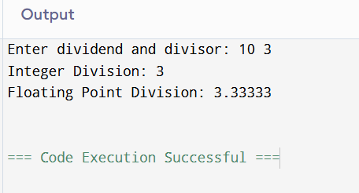

Q19:

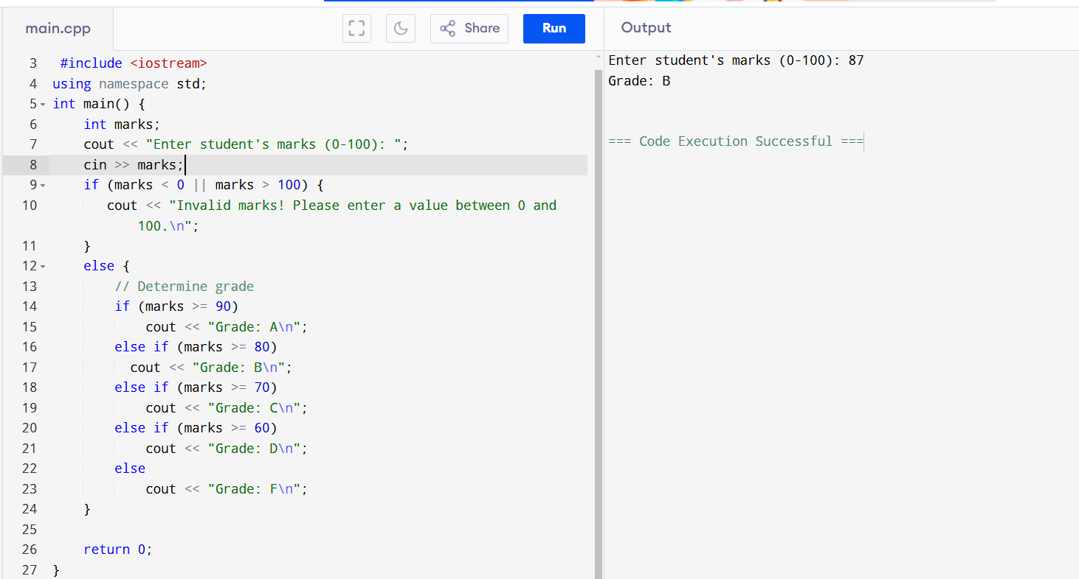

Q29:

#include <iostream>

using namespace std;

int main(){

int choice;

double num1,num2,result;

do{

cout<<"1.add"<<endl;

cout<<"2. sub"<<endl;

cout<<"3.mult"<<endl;

cout<<"4.div"<<endl;

cout<<"5. exit"<<endl;

cout<<"enter your choice:";

cin>>choice;

if(choice>=1 && choice<=4){

cout<<"enter 2 numbers:"<<endl;

cin>>num1>>num2;

}

switch(choice){

case 1:

result=num1+num2;

cout<<"result is:"<<result<<endl;

break;

case 2:

result=num1-num2;

cout<<"result is:"<<result<<endl;

break;

case 3:

result=num1*num2;

cout<<"result is:"<<result<<endl;

break;

case 4:

if(num2!=0){

result=num1/num2;

cout<<"result is:"<<result<<endl;

}else{

cout<<"division is not allowed"<<endl;

}

break;

case 5:

cout<<"exiting the program "<<endl;

default:

cout<<"invalid choice";

}

}while(choice!=5);

return 0;

}

Output:

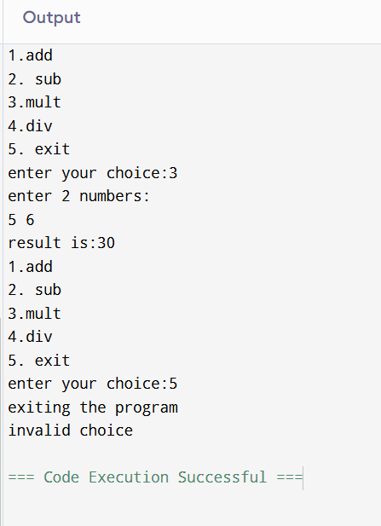

Q21:

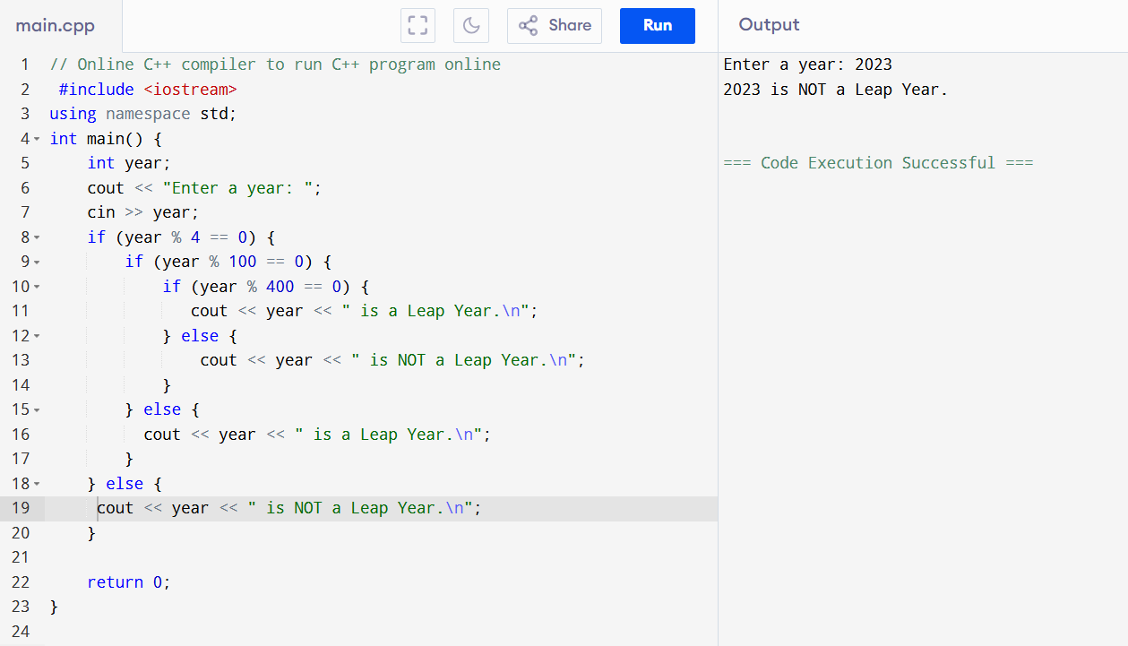

Q22:

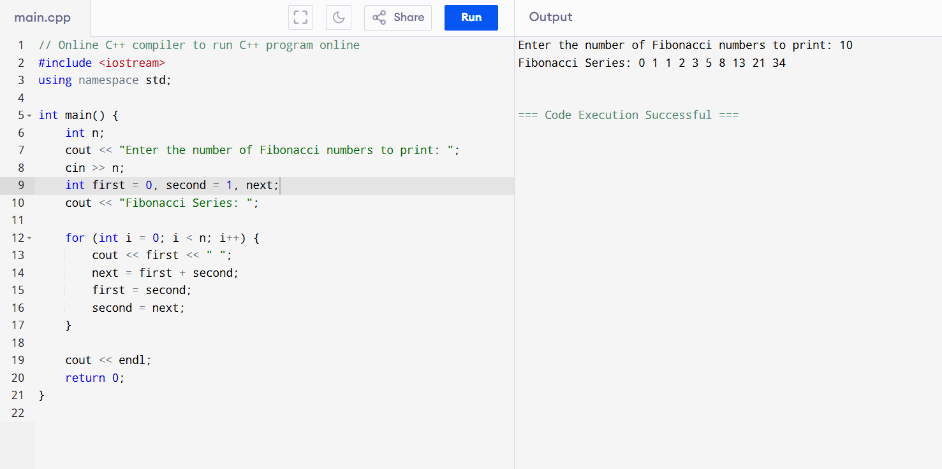

Q23:

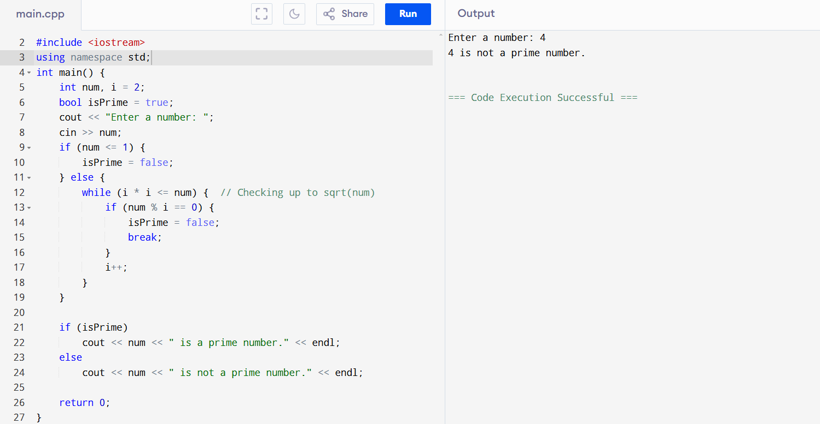

Q24:

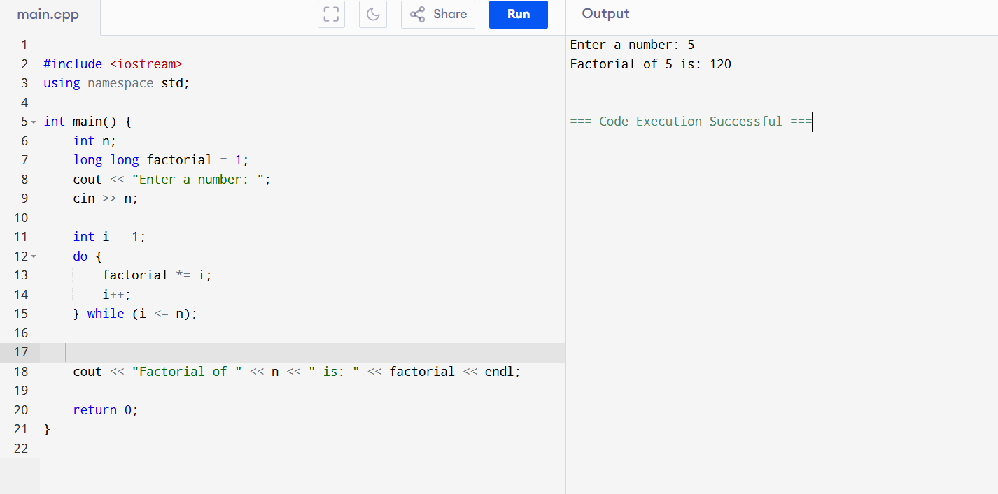

Q26:

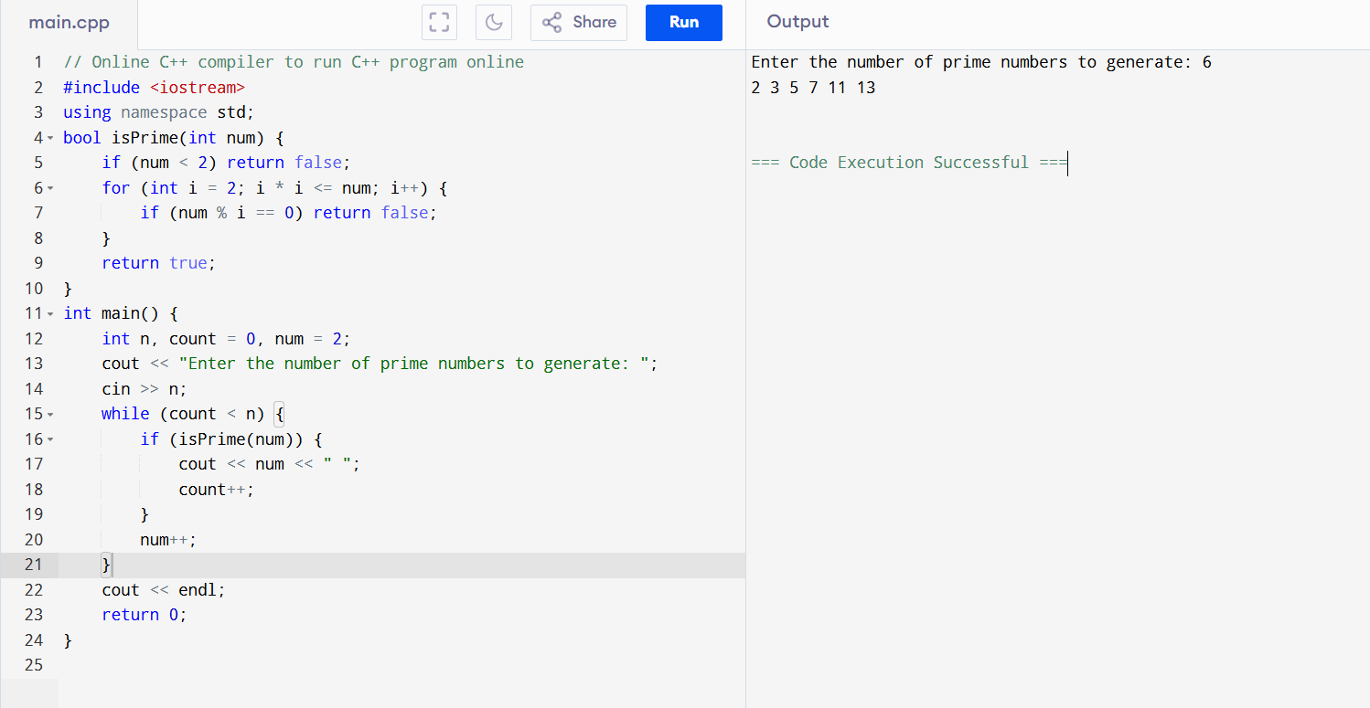

Q27:

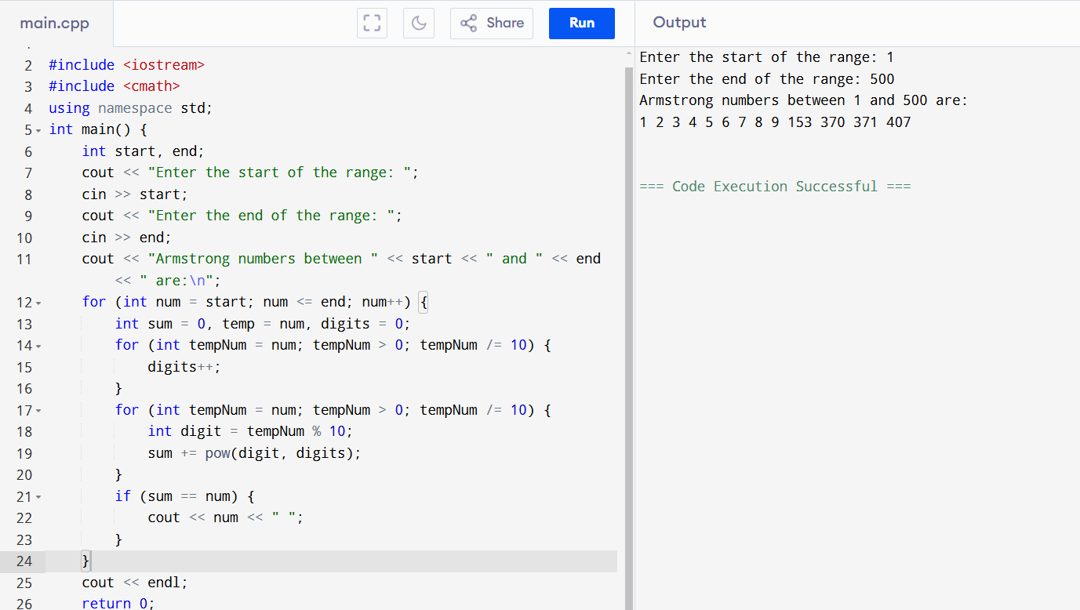

Q29:

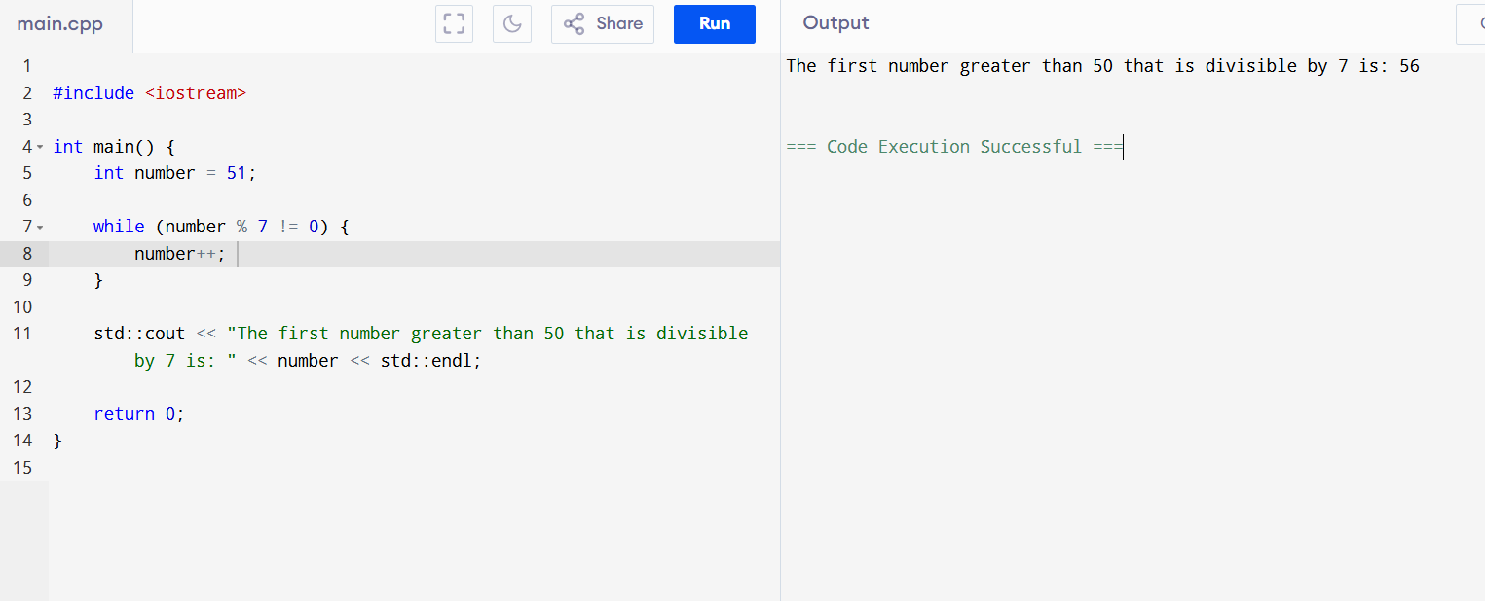

Q30:

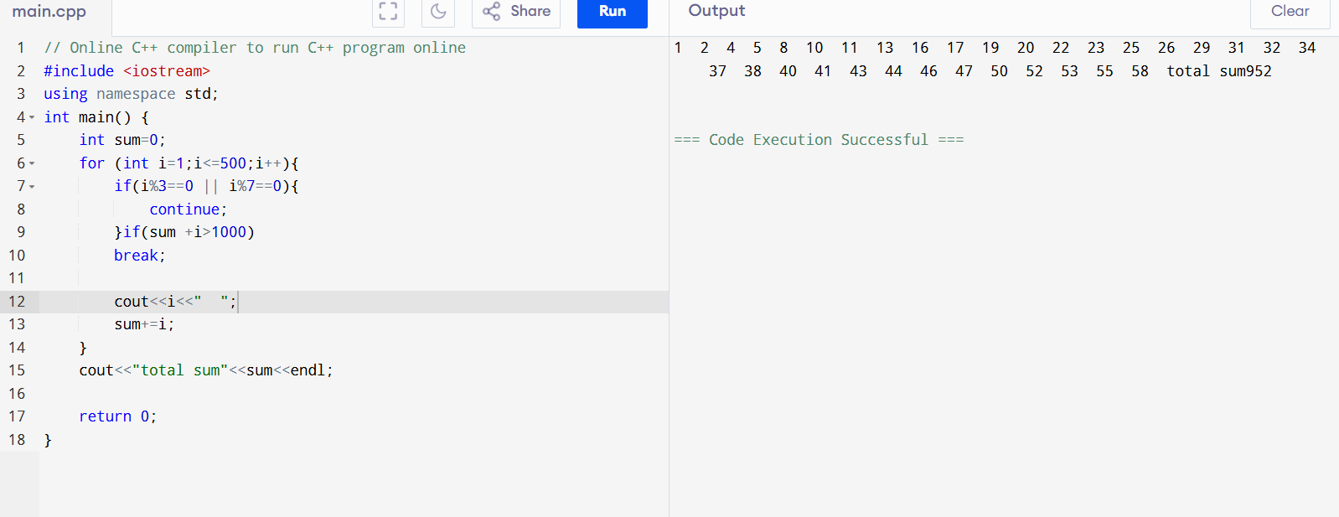

Q31:

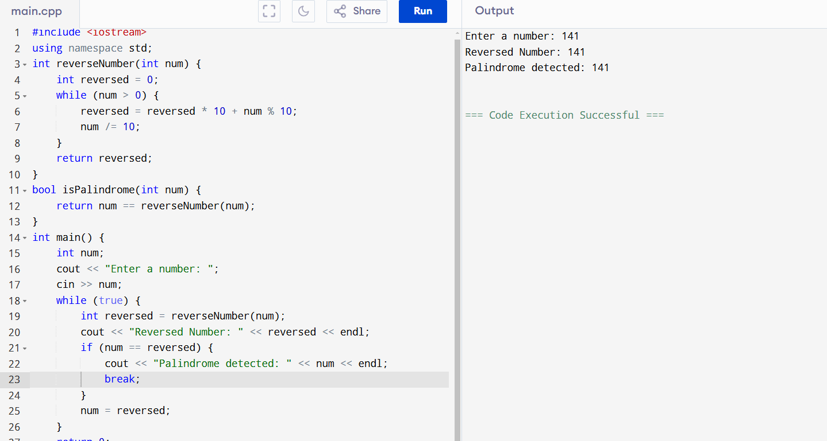

Q35:

